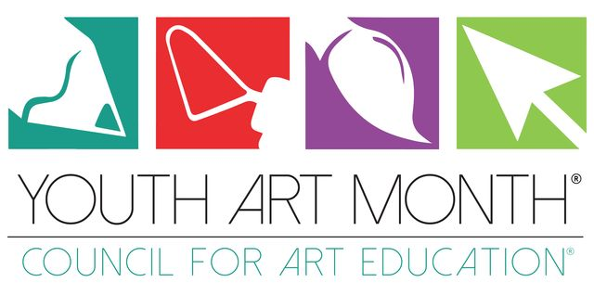

Art Teachers…Get Ready for Youth Art Month (YAM)!

Because this year has been extraordinary, we’ve decided to make Youth Art Month extraordinary as well with new sponsors and amazing prizes for students and teachers with winning entries! In addition to our YAM Flag/Banner contest we are adding a TAEA YAM Challenge!
TAEA YAM CHALLENGE
The TAEA YAM Challenge will consist of weekly art prompts for the month of March resulting in a virtual gallery on Instagram much like “Inktober.”

HOW IT WORKS:
• You will assign the prompts to your students each week.
• You will pick your best piece each week from each grade or art section
and post to Instagram with the hashtag #tnyam
• The YAM Chairman will then repost a select group of images to @yamtaea where the
Tennessee YAM Gallery will be displayed.

Here are the weekly YAM Challenge Prompts:
* Week 1: March 1-5
Create a work of art featuring the TN State bird (The Mockingbird)
* Week 2: March 8-12
Create a work of art featuring your hand holding an object that is made or grown in TN
* Week 3: March 15-19
Create a work of art that represents your TN hometown
* Week 4: March 22-26
Design a new license plate for the state of TN

These prompts could be used for the following:
Bell Work, sketchbook assignments, early finisher work, homework assignments, honors assignments, regular or virtual classroom assignments

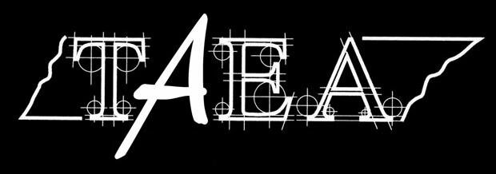
2020-21 YAM BANNER CONTEST
The theme for the banner contest this year is
Art Connects Us

Deadline for entry is January 15, 2021
Winners announced January 29, 2021

Submit up to 10 entries per school per category:
Elementary (Grades K-5), Middle School (Grades 6-8)
High School (Grades 9-12)

Please email artwork and the attached forms to Melanie Anderson: melanie.anderson@acsk-12.org

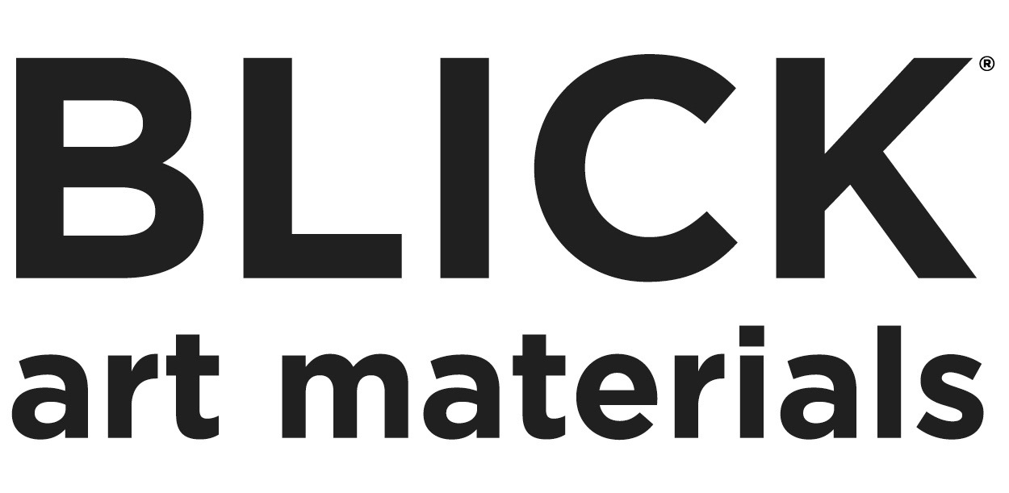

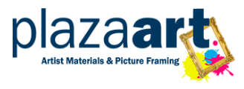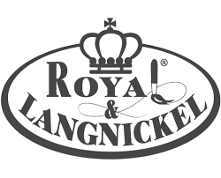

2020-21 YAM BANNER CONTEST
Art Connects Us
Student Prizes:
Student Grand Prize Winner:
• Blick: $500 Student Award (Gift Certificates and art supplies)
• Plaza Arts: $200 Gift Card
• Royal & Langnickel Brush Set
• Kolormondi Minis

Elementary, Middle and High School level winners:
• Blick Art Materials $100 Student Award (Gift Certificates and art supplies)
• Plaza Arts: $100 Gift Card
• Royal & Langnickel Brush Set
• Kolormondi Minis

Teacher Prizes:
Grand Prize Winning Teacher:
• Blick: $1000 Teacher Award (Gift Certificates and art supplies)
• Plaza Arts: $200 Gift Card
• The Art of Education University: 1 one-year bundled subscription to PRO Learning and FLEX Curriculum
• Royal & Langnickel: Class Brush Sets (valued at $150-$200)

Elementary, Middle and High School level winners:
• Blick: $300 Teacher Award (Gift Certificates and art supplies)
• Plaza Arts: $100 Gift Card

Please email the artwork and the attached forms to Melanie Anderson: melanie.anderson@acsk-12.org

